Creating a Data Service[¶](https://ei.docs.wso2.com/en/latest/micro-integrator/develop/creating-artifacts/data-services/creating-data-services/#creating-a-data-service)

Follow the instructions given below to create a new data service artifact.

**Tip**

You can also use a sample template to create your data service.

1. Open the **Getting Started** view of WSO2 Integration Studio (**Menu -> Help -> Getting Started**).
2. In the Getting Started view, go to the **Data Service** tab and select the **REST Data Service** example.

Instructions[¶](https://ei.docs.wso2.com/en/latest/micro-integrator/develop/creating-artifacts/data-services/creating-data-services/#instructions)

Create the data service artifact[¶](https://ei.docs.wso2.com/en/latest/micro-integrator/develop/creating-artifacts/data-services/creating-data-services/#create-the-data-service-artifact)

Follow the steps given below to create the data service file:

1. Right-click the **Data Service Config** module in the project explorer and go to **New -> Data Service**.

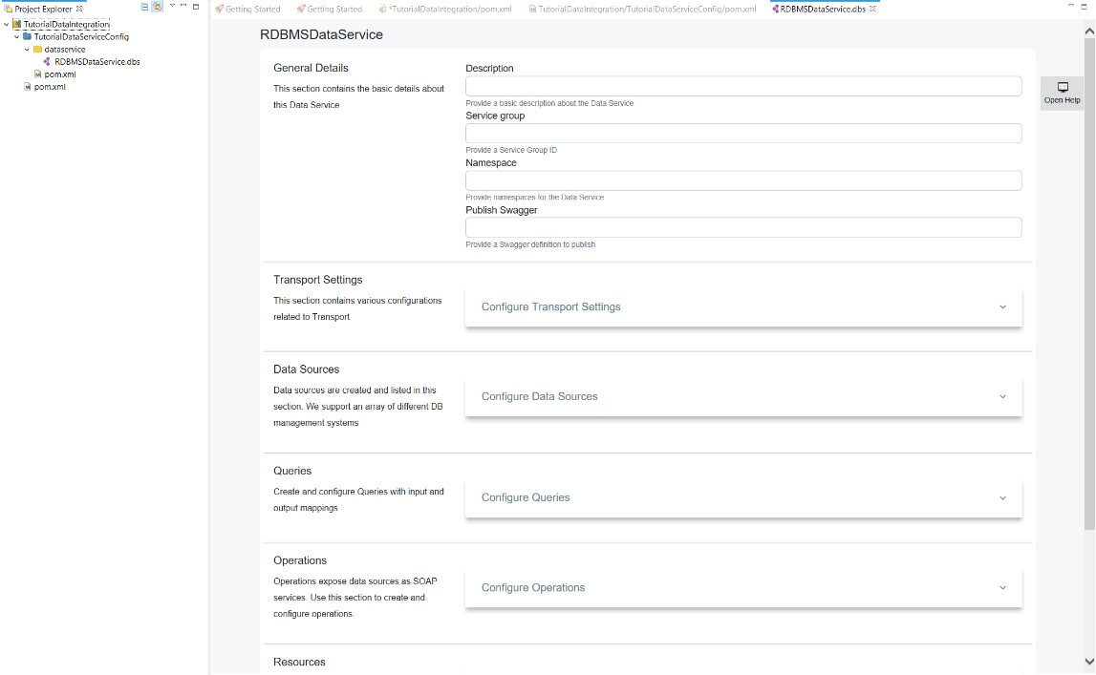

1. In the **New Data Service** wizard that opens, select **Create New Data Service** and click **Next**.

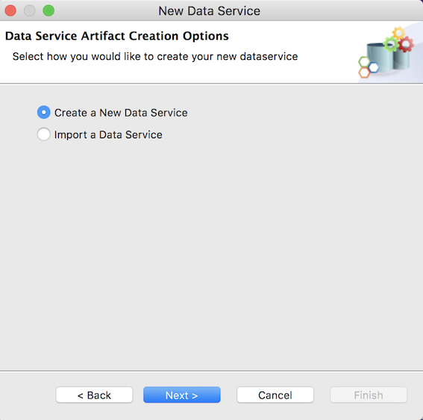

1. Enter a name for the data service and click **Finish**.

A data service file (DBS file) will now be created in your data service project as show below.

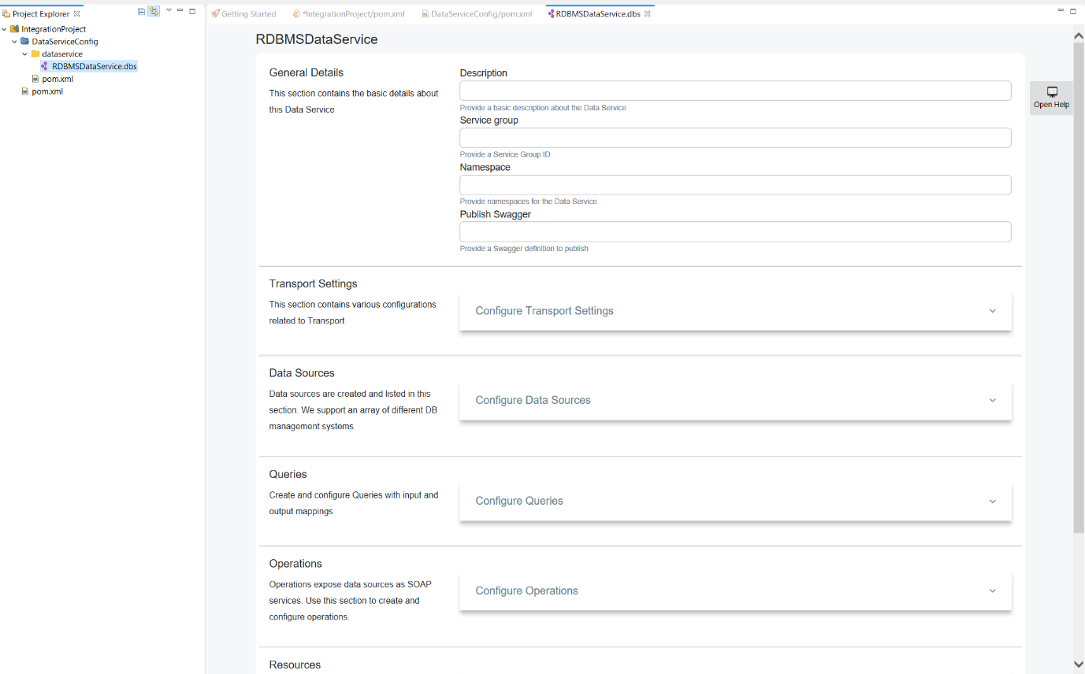

Adding a datasource[¶](https://ei.docs.wso2.com/en/latest/micro-integrator/develop/creating-artifacts/data-services/creating-data-services/#adding-a-datasource)

You can configure the datasource connection details using this section.

1. Click **Data Sources** to expand the section.

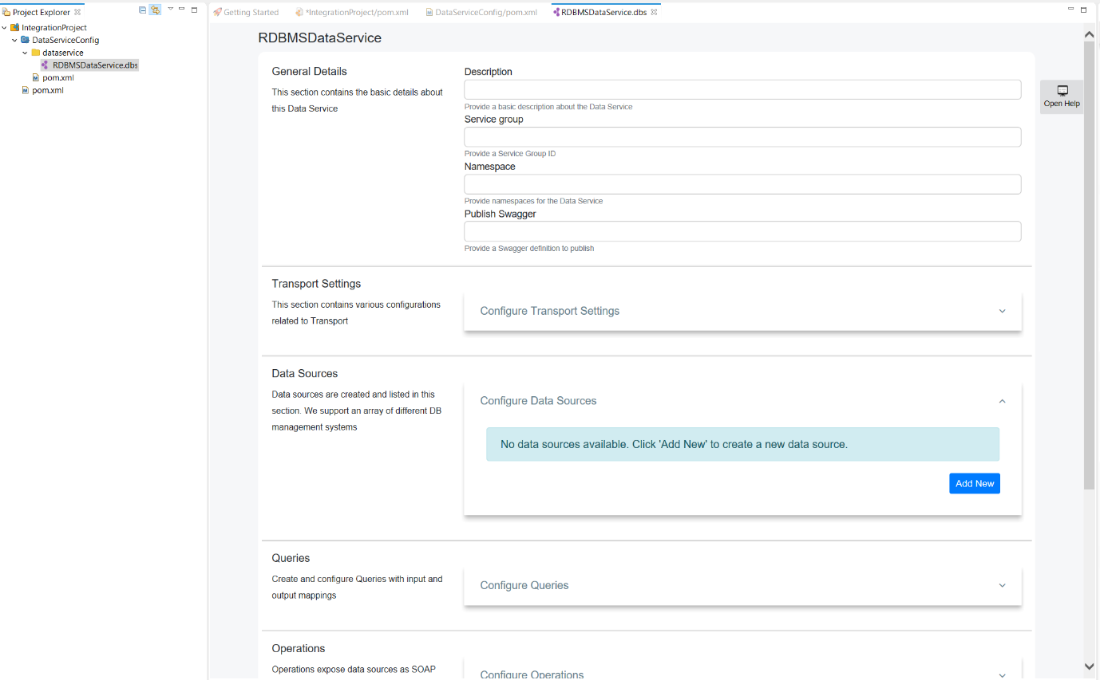

1. Click **Add New** to open the **Create Datasource** page.

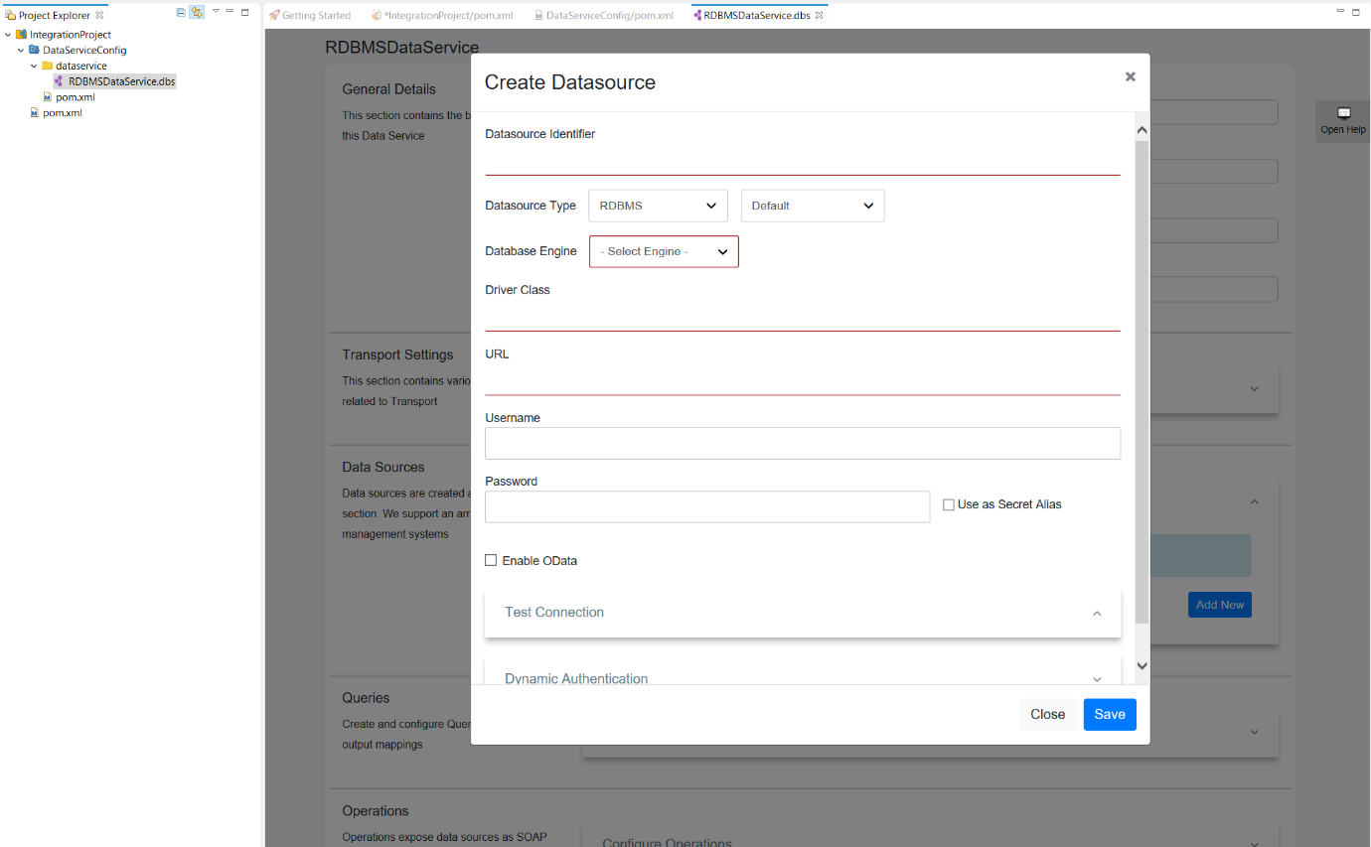

1. Enter the datasource connection details.
2. Click **Test Connection** to expand the section.

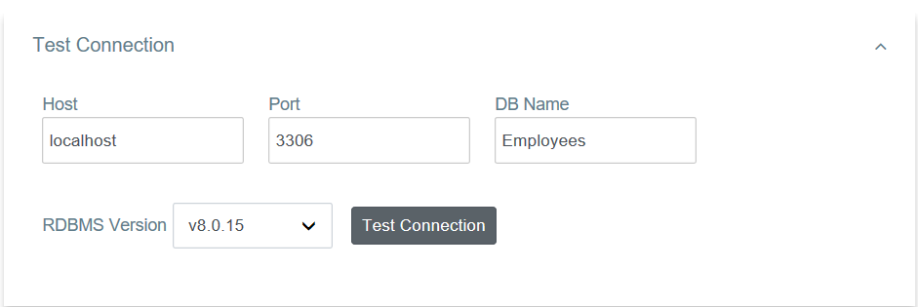

1. Click the **Test Connection** button to verify the connectivity between the MySQL datasource and the data service.
2. Save the data service.

Creating a query[¶](https://ei.docs.wso2.com/en/latest/micro-integrator/develop/creating-artifacts/data-services/creating-data-services/#creating-a-query)

You can configure the main query details using this section.

1. Click **Queries** to expand the section.

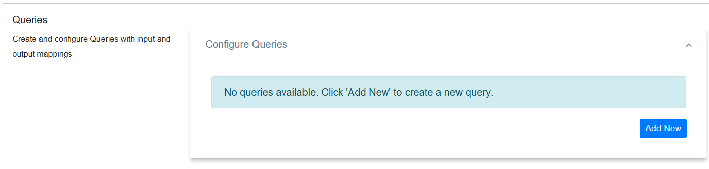

1. Click **Add New** to open the **Add Query** page.

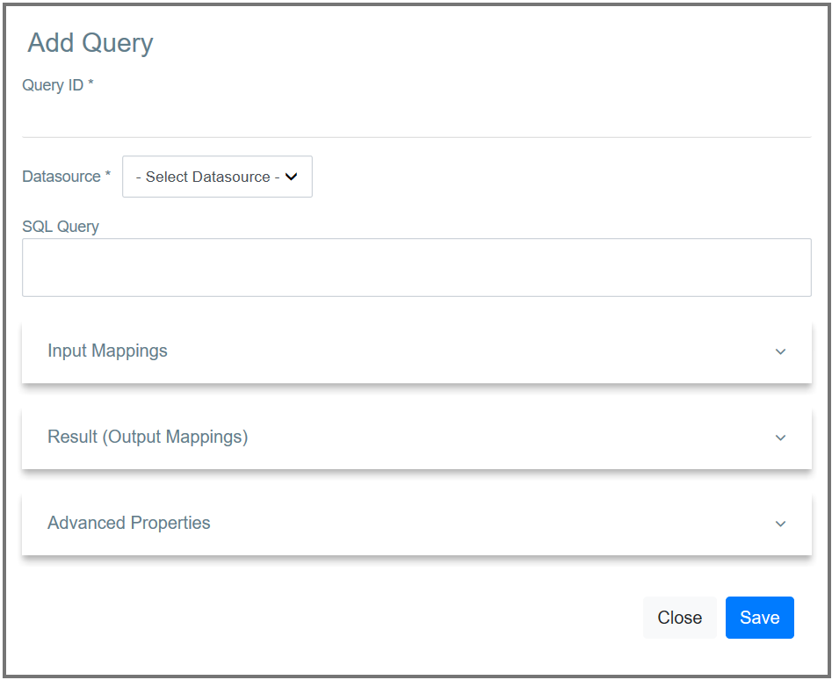

1. Enter the following query details.

|  |  |
| --- | --- |
| Parameter | Description |
| Query ID | Give a unique name to Identify the Query. |
| Datasource | All the datasources created for this data service are listed. Select the required datasource from the list. |
| SQL Query | You can enter the SQL query in this text box. |

**Input mapping**[**¶**](https://ei.docs.wso2.com/en/latest/micro-integrator/develop/creating-artifacts/data-services/creating-data-services/#input-mapping)

You can configure input parameters for the query using this section.

1. Click **Input Mappings** to expand the section.

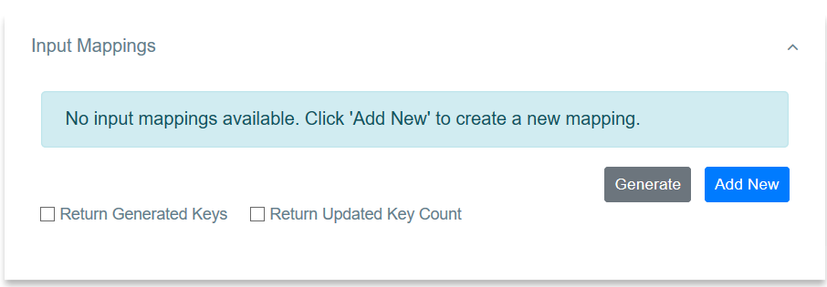

1. There are two ways to create the mapping:
   * You can click **Generate** to automatically generate the input mappings from the SQL query.
   * If you want to add a new input mapping:
     1. Click **Add New** to open the **Add Input Mapping** page.

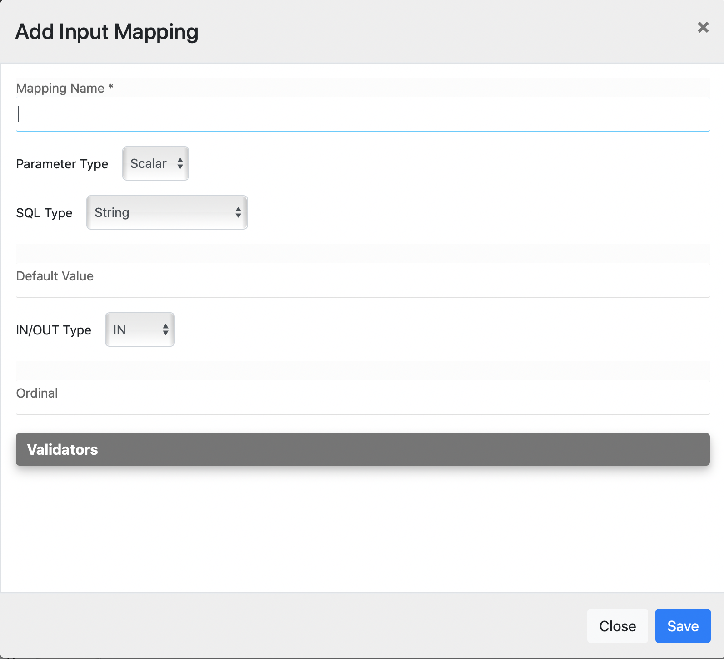

* + 1. Enter the following input mapping details:

|  |  |
| --- | --- |
| Parameter | Description |
| Mapping Name | Give a name for the mapping. |
| Parameter Type | The parameter type. |
| SQL Type | The SQL type. |

* + 1. Save the input mapping.

Shown below is an example query with input mapping:

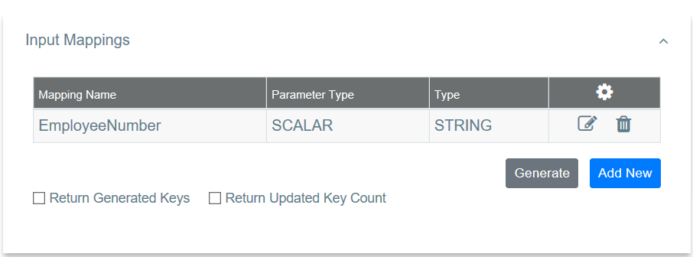

**Result (Output Mappings)**[**¶**](https://ei.docs.wso2.com/en/latest/micro-integrator/develop/creating-artifacts/data-services/creating-data-services/#result-output-mappings)

You can configure output result parameters for the query using this section.

1. Click **Result (Output Mappings)** to expand the section. 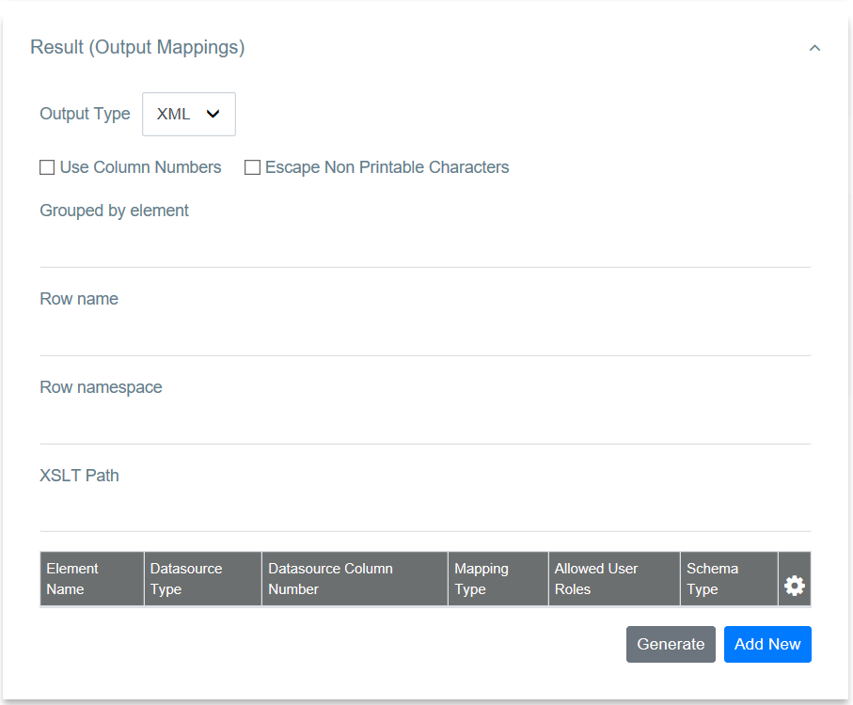
2. Enter the following details:

|  |  |
| --- | --- |
| Property | Description |
| Grouped by Element | Employees |

1. There are two ways to create the output mapping:
   * You can click **Generate** to automatically generate the output mappings from the SQL query.
   * Alternatively, you can manually add the mappings:
     1. Click **Add New** to open the **Add Output Mapping** page.

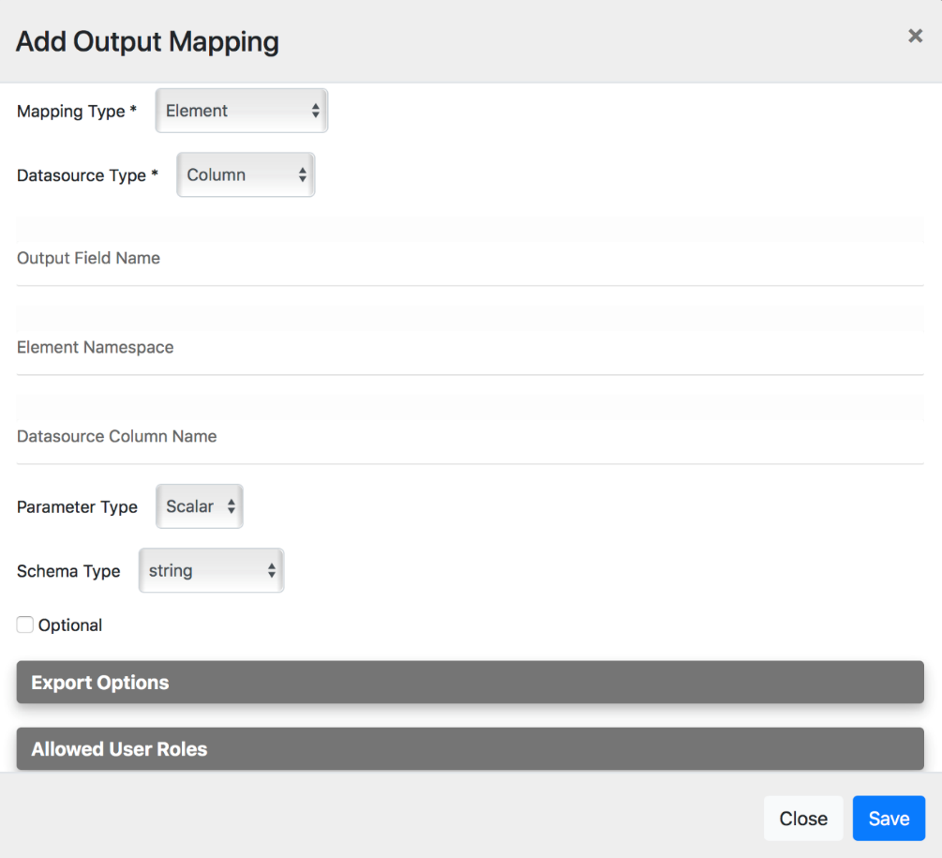

* + 1. Enter the following output element details.

|  |  |
| --- | --- |
| Property | Description |
| Datasource Type | column |
| Output Field Name | EmployeeNumber |
| Datasource Column Name | EmployeeNumber |
| Schema Type | String |

* + 1. Save the element.
    2. Follow the same steps to create the remaining output elements.

Shown below is an example query with output mappings:

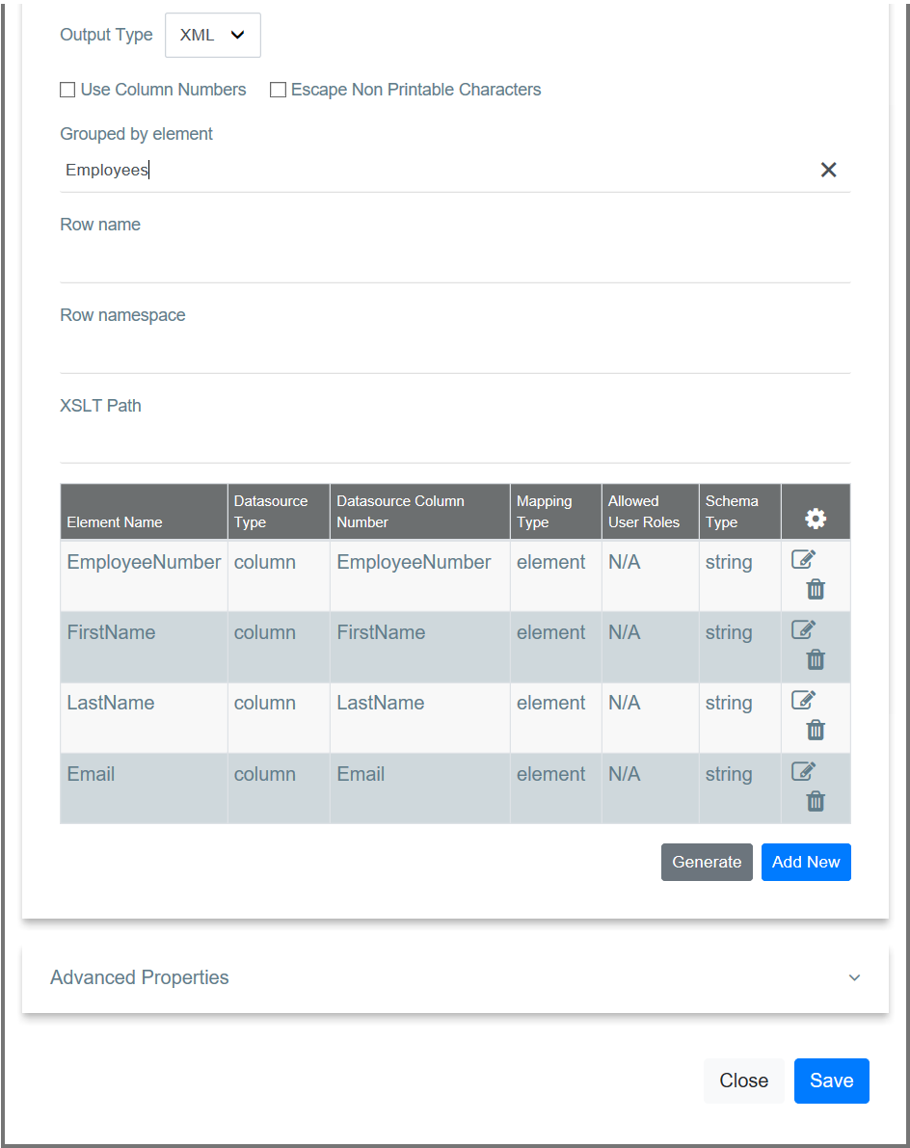

**Advanced properties**[**¶**](https://ei.docs.wso2.com/en/latest/micro-integrator/develop/creating-artifacts/data-services/creating-data-services/#advanced-properties)

Click **Advanced Properties** to expand the section and add the required parameter values.

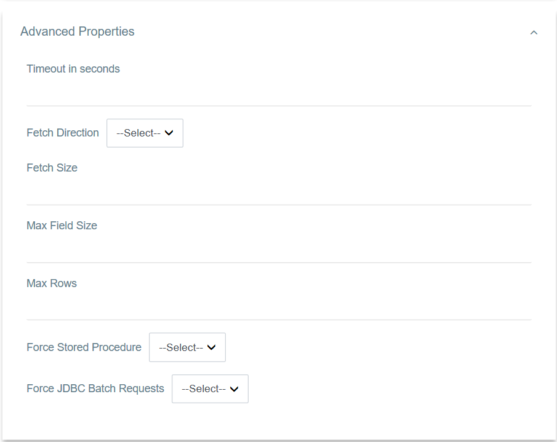

The data service should now have the query element added.

Adding a SOAP operation[¶](https://ei.docs.wso2.com/en/latest/micro-integrator/develop/creating-artifacts/data-services/creating-data-services/#adding-a-soap-operation)

Use this section to configure a SOAP operation for invoking the data service.

1. Click **Operations** to expand the section.

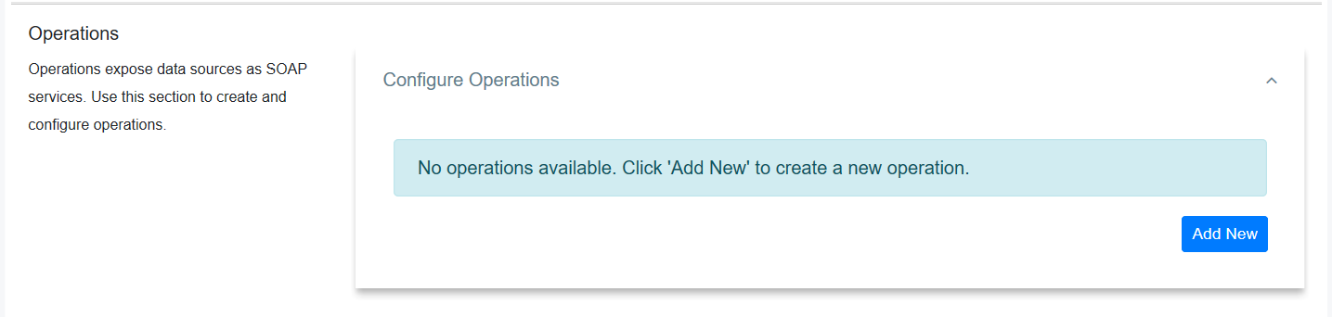

1. Click **Add New** to add a SOAP Operation for your data service.

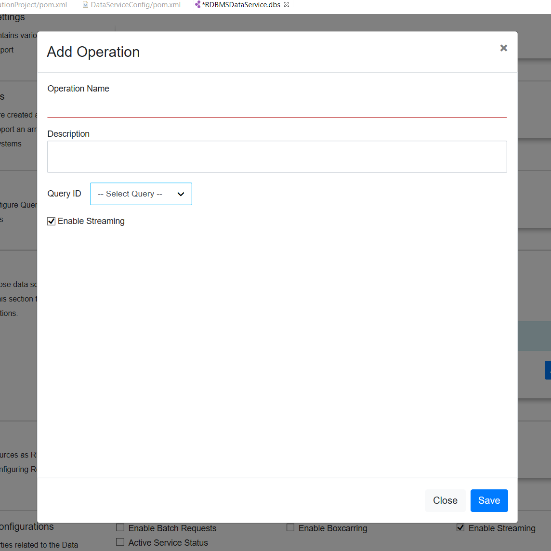

1. Enter the following information:

|  |  |
| --- | --- |
| Parameter | Description |
| Operation Name | Give a name to the SOAP Operation. |
| Query ID | Select the Query from the listed queries. |
| Operation Parameters | Click **Add New** to add new parameters to the operation. |

Adding a Resource[¶](https://ei.docs.wso2.com/en/latest/micro-integrator/develop/creating-artifacts/data-services/creating-data-services/#adding-a-resource)

Use this section to configure a REST resource for invoking the data service.

1. Click **Resources** to expand the section. 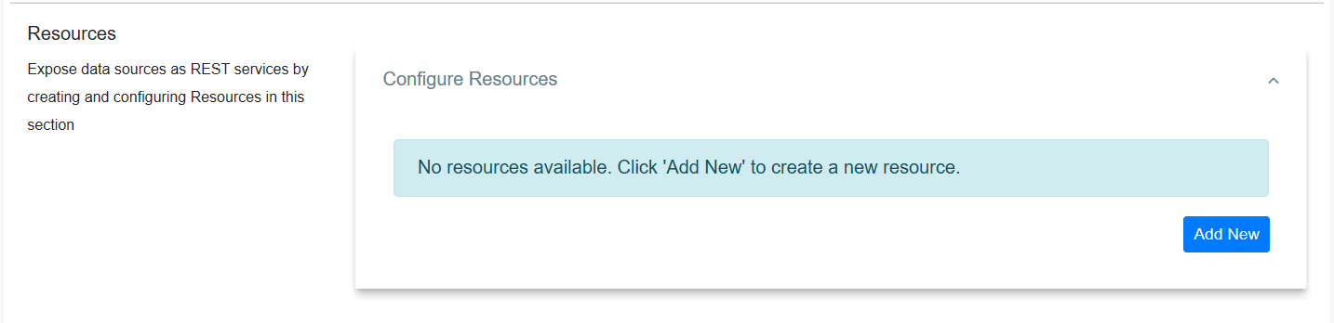
2. Click **Add New** to add a new resource.

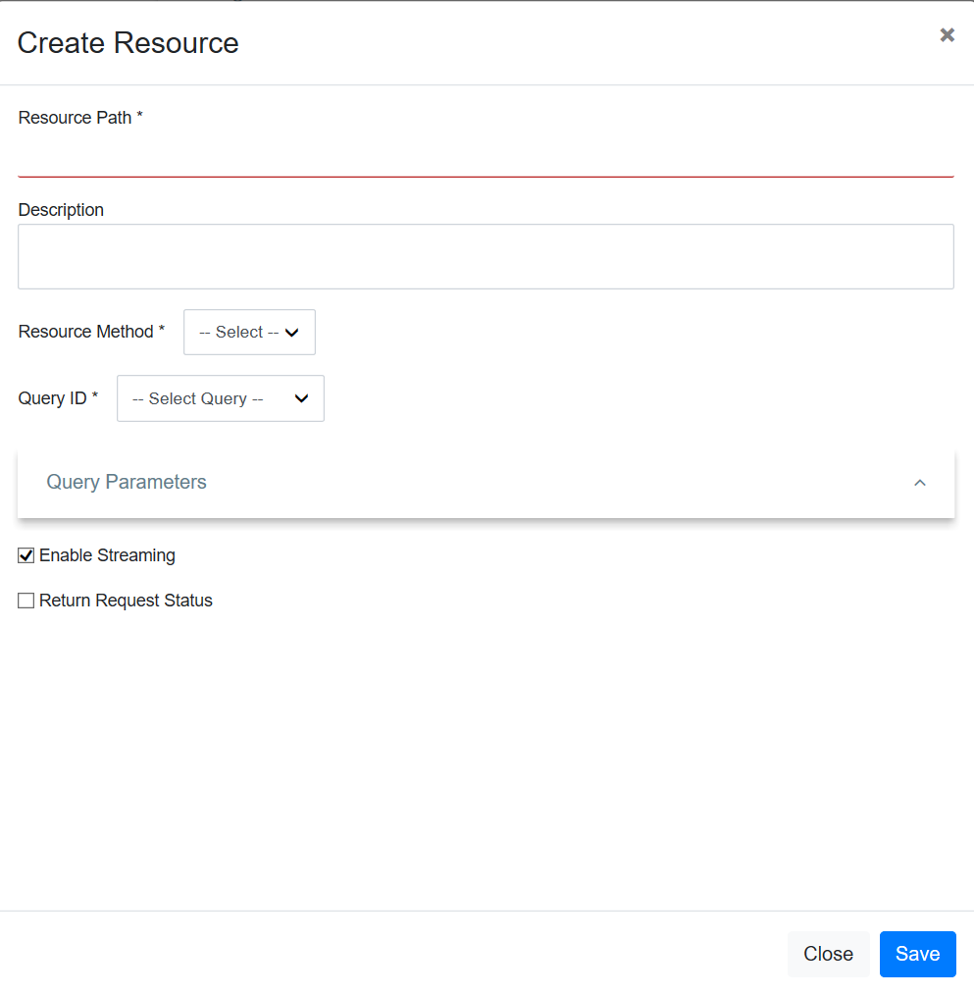

1. Give the following details to create the REST resource.

|  |  |
| --- | --- |
| Parameter | Description |
| Resource Path | Give the HTTP REST resource path you need to expose. |
| Query ID | Select the Query ID from the drop down list that you need to expose as a REST resource. |

1. Click **Save** to add the resource to the data service.

The data service should now have the resource added.